Individual Weekly Report for Sam Baranov

Gym App

June 30, 2025

# Accomplishments

* Finalized the project option I will be going forward with for the capstone
* Conducted research on possible frameworks that can be used to implement this project and settled on Flutter with SQLite using Drift as the most fitting option. Compose and React were rejected.
* Drafted my personal design specifications document, which included some extra categories, such algorithm behavior definitions, non-functional requirements, and most importantly stretch goals.
* Drafted formal design specifications document
* Started Figma prototype work
* Settled on the overall architectural pattern for the project

# Weekly Activities

| Activity / Task / Work | Hours | Status |
| --- | --- | --- |
| Informal Feature Outlining | 1 | Complete |
| Informal Design Specifications work | 6.5 | Complete |
| Figma Prototype work | 4 | In progress |
| Tech Stack research | 3.5 | Complete |
| Formal Design Specifications initial draft | 1.5 | Complete |
| Status Report 2 | 0.5 | Complete |
| Architecture research and diagram | 2 | In progress |
| Instructor Meeting | 0.5 | Complete |
| Development environment set-up | 1 | In progress |
| Formal Design Specifications Revised Draft | 1 | In progress |
| **Weekly Total** | **21.5** |  |
| Previous Weekly Cumulative Total (Carry Over) | 12.5 |
| **Current Cumulative Total** | **34** |

# Plans for Next Week

| Activity / Task / Work | Est Hours |
| --- | --- |
| Figma Prototype work | 10-20 |
| Finalize Design Spec | 2 |
| Draft Contract | 2 |
| Begin data layer implementation | 3 |

# Response to Feedback

For the overall project direction of a gym app, I have received extensive feedback from both instructor and outside sources. It appears to be the best idea for the capstone project after all, being in-line with the project requirements, as well as being a good display of CS skills learned during the major.

Received architecture diagram feedback from instructor, it appears to meet the requirements of the Design Specification document, so I will keep the format and focus on content changes.

# Other Reflections

This week has been heavy on research for overall tooling and architecture research for the implementation of the project. I have indirectly outlined the direction for this research during the Design Specification work, which helped me narrow down my framework and pushed me to change my initial architecture plan.

This result is me settling on Flutter, a framework I have experience with. I was initially leaning towards react, due to need for visualization, to I have found flutter have a stable implementation for data visualization.

Probably biggest conceptual learning was the “Clean Architecture” pattern. I initially assumed MVVM would be the most fitting, but it seems that “Clean Architecture” is a more fitting pattern, due to presence of more complex logic that acts upon the data layer, which means that Presentation/Domain/Data split is probably more fitting.

Overall, this has been an information and research heavy week, with a lot of learning in regards to architecture and overall industry standards of Android development. I am expecting majority of the time next week to be spent working on the Figma prototype.

# Comments, Issues, Notes, Anything Else?

My only question is how to approach research. It has been informing a lot of the documentation work, but I am not sure what to do with more “informal” sources, which dominate things such as framework comparisons?

# Evidence of Work

## Figma Prototype Work

Initial work on the prototype. This was meant to be a low-fidelity design, but I will likely restart now that I have a better idea, and I realized that Figma supports Material 3 UI components, which should speed it up greatly.

## Design Spec Work

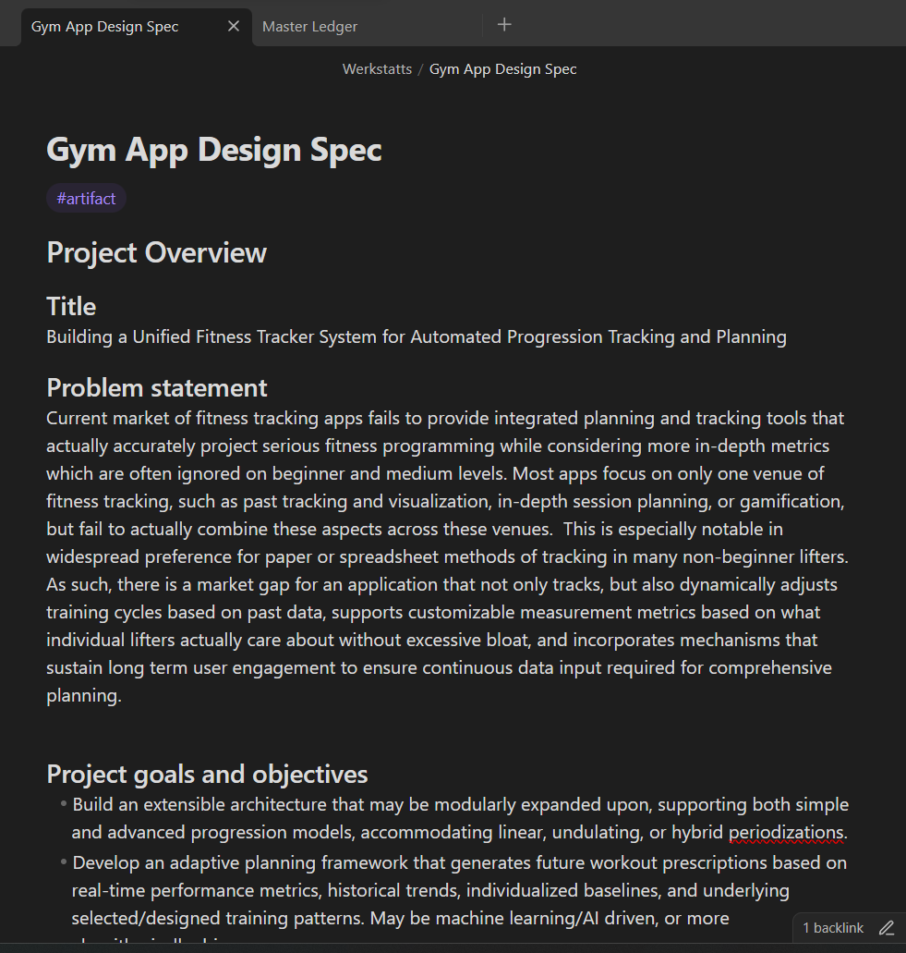

The “informal” design spec I am keeping separately in Obsidian. I realized that there were some aspects of development process that I really wanted to include iterations, but the official design didn’t include it. Plus this is easier to quickly change since I have it synced.

## Informal Feature Outline

Part of the feature outline I’ve done before the design spec. Not going to post them all here because it’ll be very long, but I’ve split down requirements along main aspects of gym tracking. This was used to inform the design spec.

## Architectural Diagram

The architectural diagram so far. I ended up moving away from pure MVVM to what appears to be called “Clean Architecture” pattern (I found this during the research), and attempted to model it. I will probably refine this further, but this is in line with the overall architecture changes that I have found after settings on Flutter as my core framework.

# Interaction Report

Interaction Type: Instructor

Interaction Date: 7/7/2025

Attendees: Instructor

## Summary of Interaction

* Discussed Design Specifications formatting
* Discussed which project option is more fitting for capstone choice
* Discussed diagram formatting for Design Specifications
* Discussed showcase pr

## Action Items

* Review Design Specifications draft feedback
* Look at Showcase 1 requirements

## Reflection on the Interaction

Main takeaway was that I finalized my decision to work on the Gym App project over a game project, despite the latter one being closer to my long-term goals. The android app provides a better opportunity to represent CS learnings, as well as being a project I already have outlined and am passionate about.

I am now working on finalizing design specification, as I have a more overall complete understanding of what needs to be done, and also know the overall direction of the project.